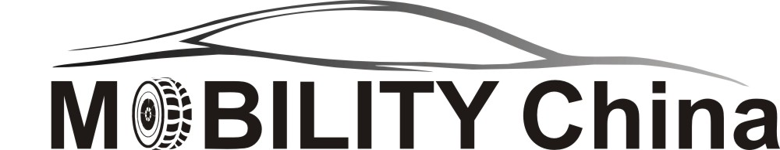
MOBILITY China 2026
Time: March 20 to 23, 2026 Venue: the Shenzhen World Exhibition & Convention Center (China)
Application and Contract Form
Welcome to participate in the MOBILITY China 2026 in Shenzhen, which focus on solutions such as electric vehicles, Autonomous driving and innovative transport concepts, held together with CIMP AutoEcosystems Expo. The organizing committee will assist each exhibitor archive great success during the show.
Company Name：
Address：__________________________________________________________________________________________ Postal code： Phone： Fax: ______________________ Contact： Position： Mobile:______________________ Website： E-mail:____________________________________________
Exhibits：
■ Book your booth：(10% more fee will be added for Corner Booth with two openings)
□ Choose standard booth or Ground Area: ㎡,Booth No. Fee
Booth Type | Specification | Price
Standard Booth | 9㎡（3×3） | USD 3,000/9㎡
Standard Booth | 18 ㎡（3×6） | USD 6,000/18㎡
Raw Space | 36㎡ At least | USD 300/㎡
■ Reserve speech slot:
□ USD 3,000/30 minutes Booking Speaker Fee
■ Book your advertisement:
A. Exhibition catalogue advertisement:
□Cover USD 5,000 □Inside Front Cover USD 2,000 □Flyleaf USD 1,500
□Back Cover USD 3,000 □Cross Page USD 2,000 □Inside Back Cover USD 2,000
B. Onsite advertisement：
□Visiting Cards/Badge String USD 10,000 □Rainbow door USD 6,000/per one
□Carrier Bags USD 6,000 □Drinking water USD 4,000
□Official Invitation Book USD 4,000 □Advertisement board USD 6,000/per one
■ Total Fee： ；Payment date: _________________________
Beneficiary：Guangzhou JS Watson Exhibition Co.,Ltd 广州嘉实沃森展览有限公司
Account Number (USD): 3602 0722 0920 1144 256
Bank Name: Industrial And Commercial Bank Of China,Guangdong Provincial Branch Guangzhou Dadao Sub-Branch （Swift: ICBKCNBJGDG，CNAPS:102581000193）
▼After the application is successful, the organizing committee will send the confirmation to the exhibitor. Please send 50% of or the full payment to the Organizing Committee by T/T within 7 working days. After the payment is received, the according invoice will be sent to the exhibitors.
The Secretary Office of the Organizing Committee:
Contact: Mr. Brian BAO Seal of the participant:
Tel: 86-020 3439 7221
Fax: 86-020 3439 7223 Signature:
Email: brianbao@jswatsonexpo.com
Website: autotech-mobility.com/english Date

